1. Using ‘apt list –upgradebles’ can check all updates available

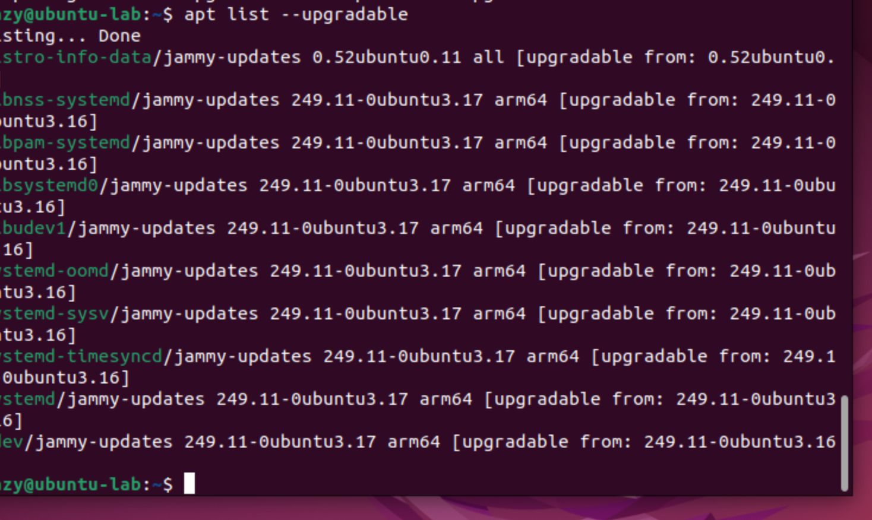

1. Sudo apt upgrade/update will start the process with some confirmation (y/n)

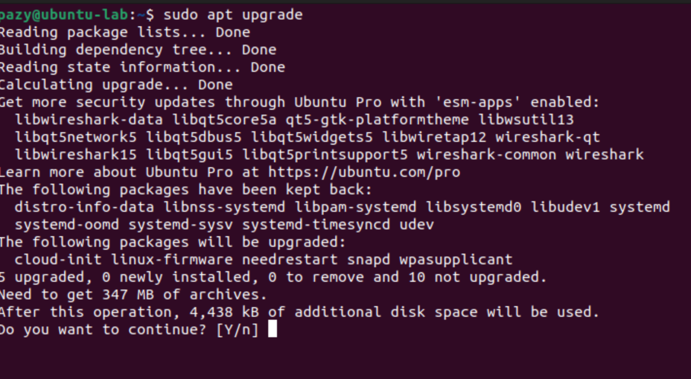

* When upgrading, the screen looks like this, rapidly changing as more stuff gets downloaded

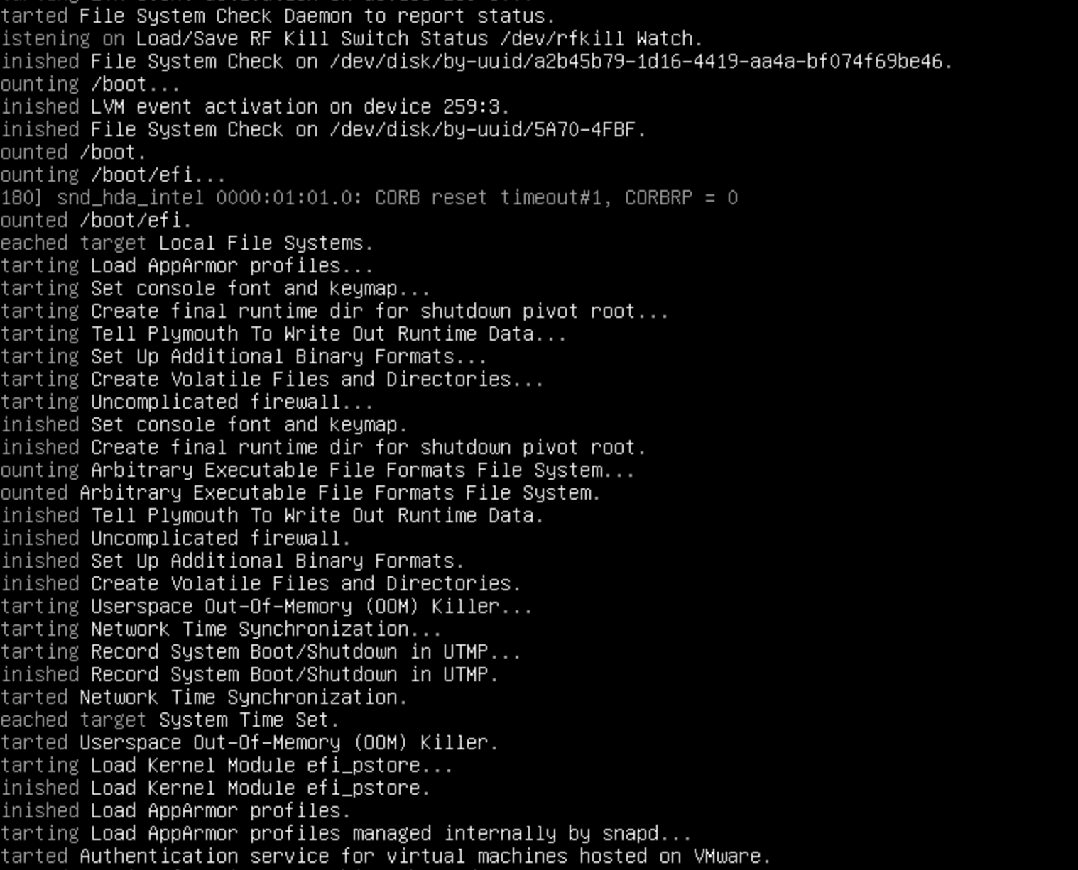

4. To get into root user, using ‘sudo su root’ will prompt the password login to begin

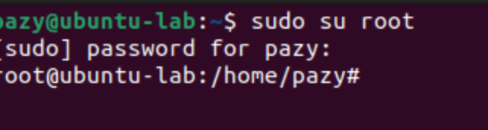

5. Using ‘adduser’ is a more complicated and advanced way of adding a user rather than using ‘useradd’

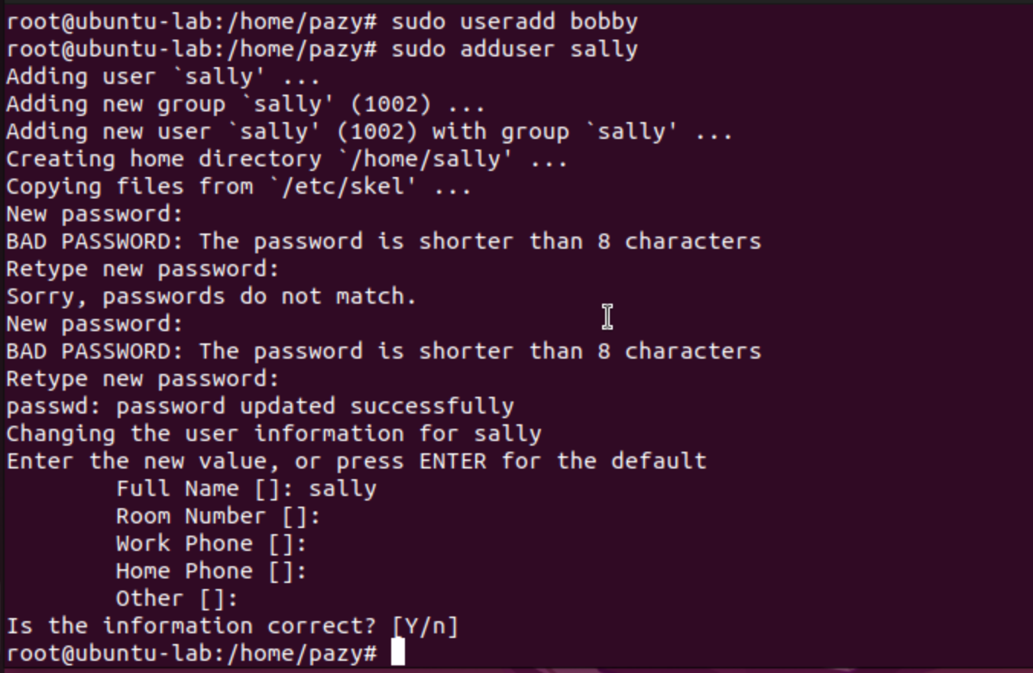

6. Sally doesn't have permission to add a user, so she gets denied

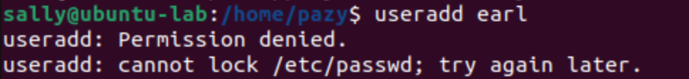

8. Using exit brings me back to the root, and using exit again brings me to my Ubuntu account. Trying to delete a non-existent user brings us to an error message like the one below

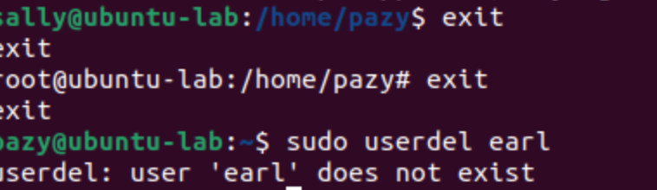

9. Using ‘sudo passwd “username”’ will change or add a password to a user, and give error messages if a password is inadequate (security risk might be that sally was allowed to use a bad password)

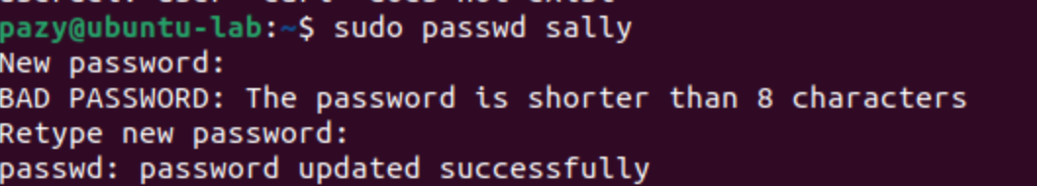

10. It's bad to stay logged in as the root user due to the security risk. With root privileges, there is nothing someone with malicious intentions can’t do.

11. Using ‘id’ gets the account ID that you are currently on



13. Using ‘usermod -aG sudo “username”’ gives a user sudo commands and allows them to do things like add users. After giving Sally sudo permissions, she can now add users:



14-16 - Using ‘sudo groupadd “groupname”’ will add a new group, and then using ‘sudo usermod -aG “groupname” “username”’ will add a user to a specific group. To check a user's groups using ‘groups “username”’ will list out all groups they are in.



17. ‘Mkdir’ is the command to make new directories. The owner is root, and the group owner is also root; the directory is executable, and the owner can read and write, the group can read, and everyone else can only execute

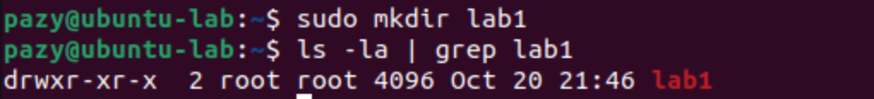

18. To make a bash file using ‘nano “name”’ brings you straight to a coding terminal. To print in bash, you use “echo”. When done to make the file executable, we use ‘chmod +x “filename”’. Finally, to run programs, we use ‘./“filename”’.



19.



20.

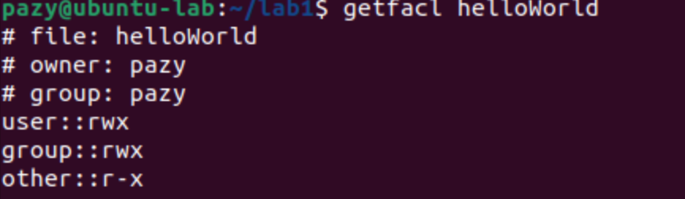

21.



